UNRESTRICTED TO BLOCKED-(13)

Home - Personal - Microsoft​ Edge
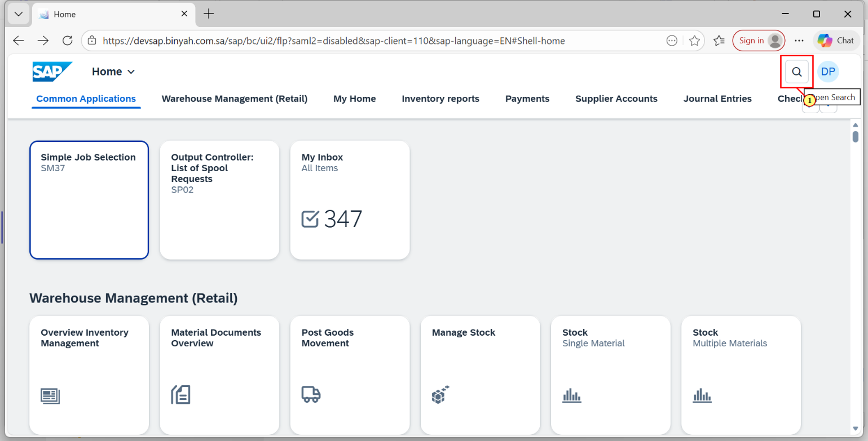
Step | Action
(1) | Click on "Search Icon".

Home - Personal - Microsoft​ Edge
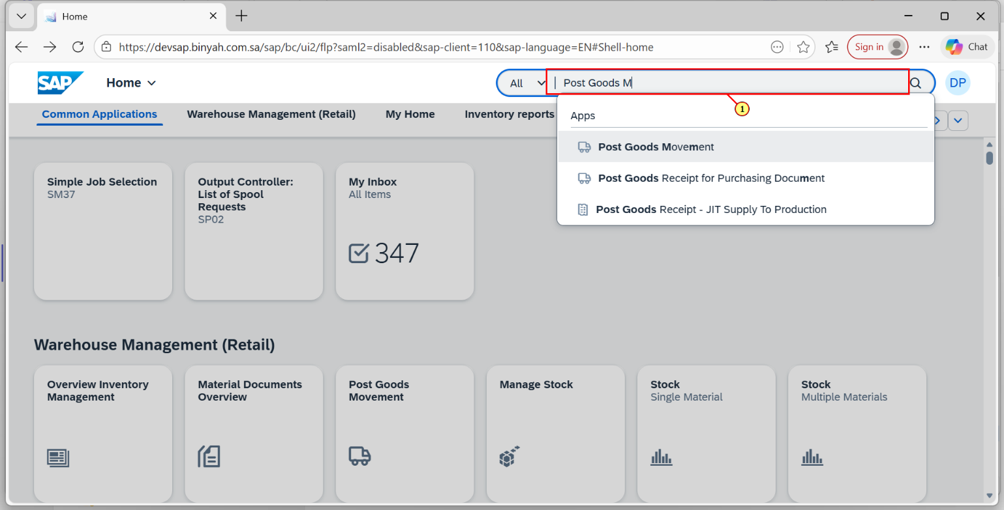
Step | Action
(1) | Search and Open "Post Goods Movement".

Transfer Posting Other - Personal - Microsoft​ Edge
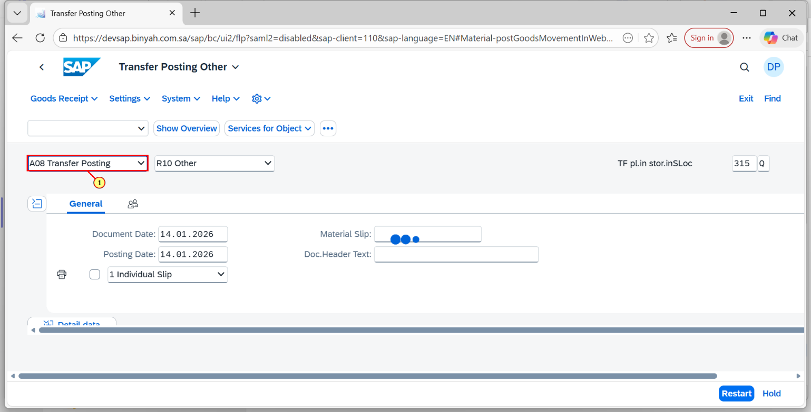
Step | Action
(1) | Select "Transfer Posting".

Transfer Posting Other - Personal - Microsoft​ Edge
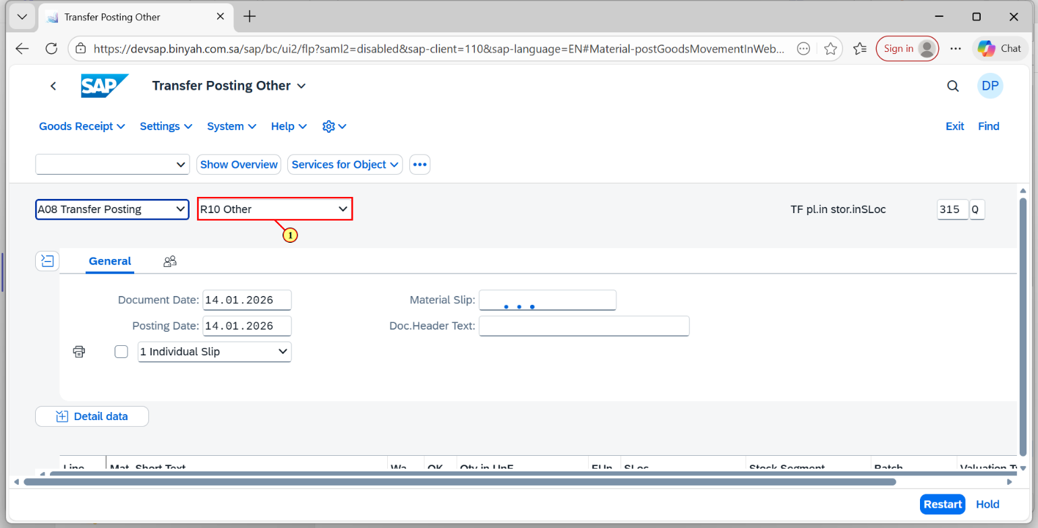
Step | Action
(1) | Select "Other".

Transfer Posting Other - Personal - Microsoft​ Edge
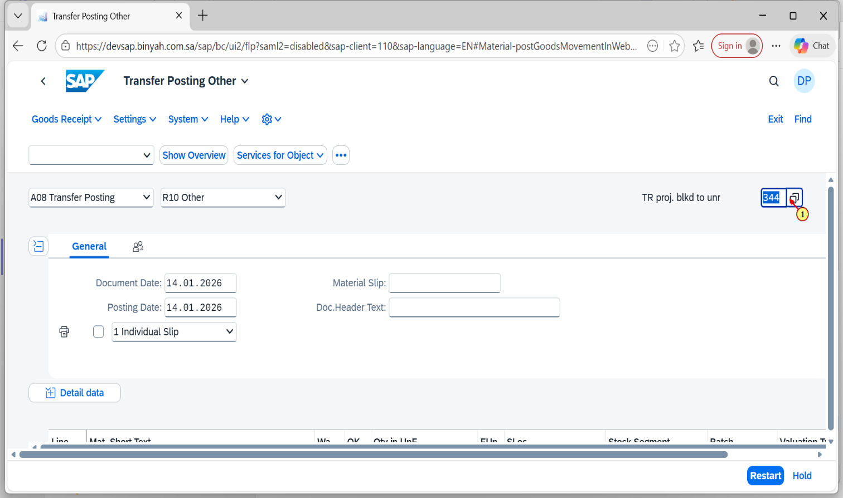
Step | Action
(1) | Enter Movement Type as "344 Q"

Transfer Posting Other - Personal - Microsoft​ Edge
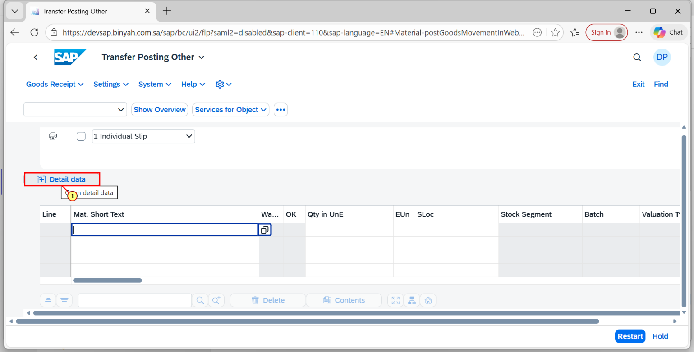
Step | Action
(1) | Click on "Detail Data".

Transfer Posting Other - Personal - Microsoft​ Edge
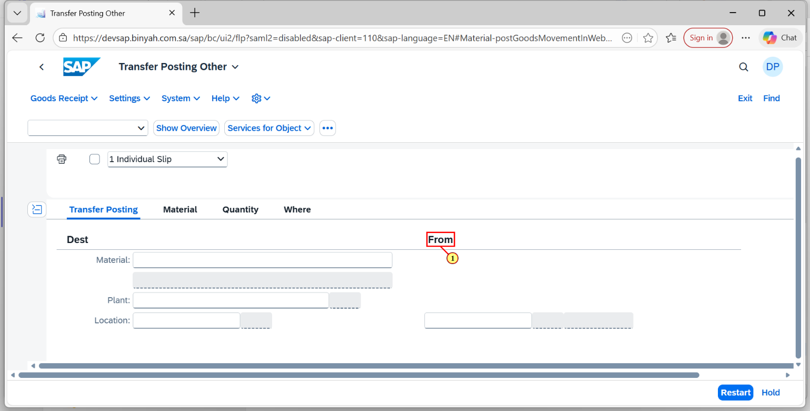
Step | Action
(1) | Click on "From"Section.

Transfer Posting Other - Personal - Microsoft​ Edge
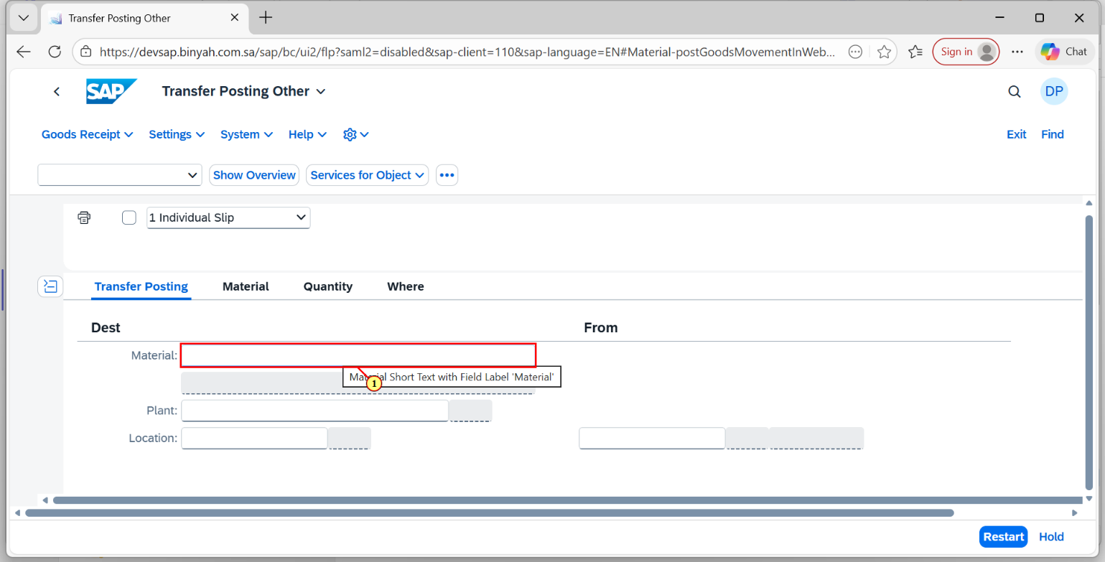
Step | Action
(1) | Enter "Material".

Transfer Posting Other - Personal - Microsoft​ Edge
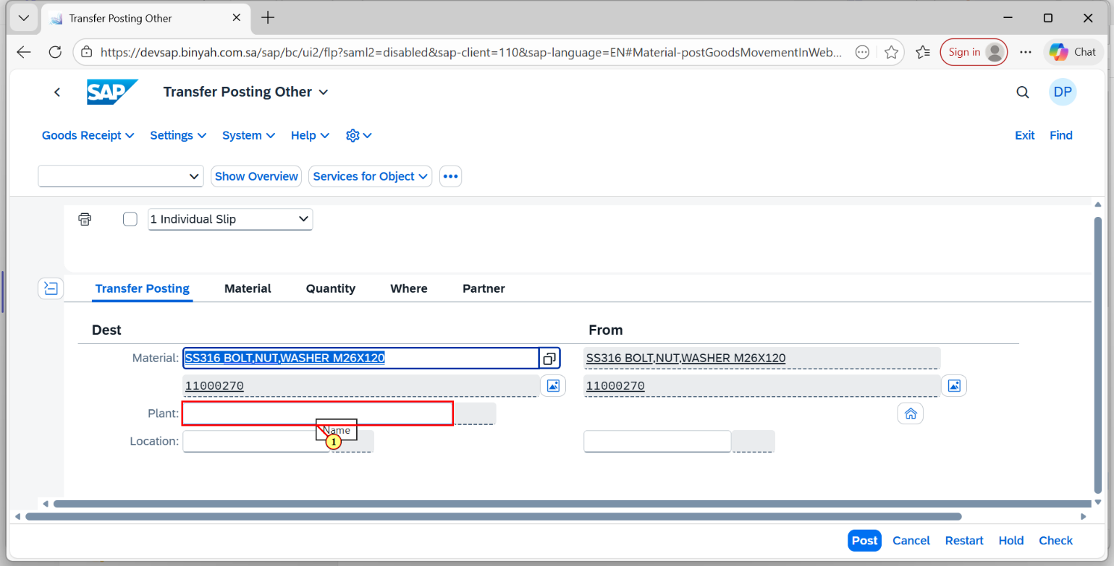
Step | Action
(1) | Enter "Plant".

Transfer Posting Other - Personal - Microsoft​ Edge
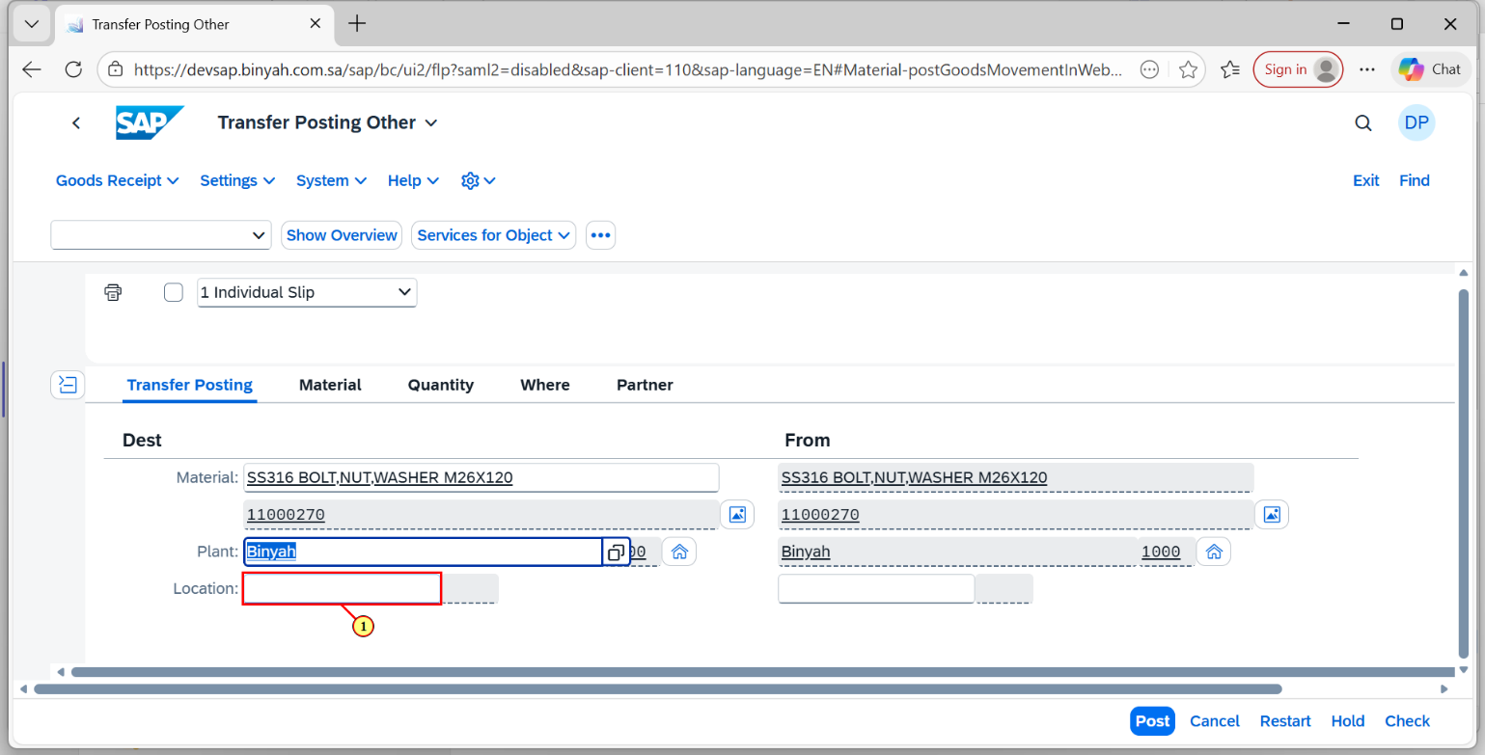
Step | Action
(1) | Enter "Storage Location".

Transfer Posting Other - Personal - Microsoft​ Edge
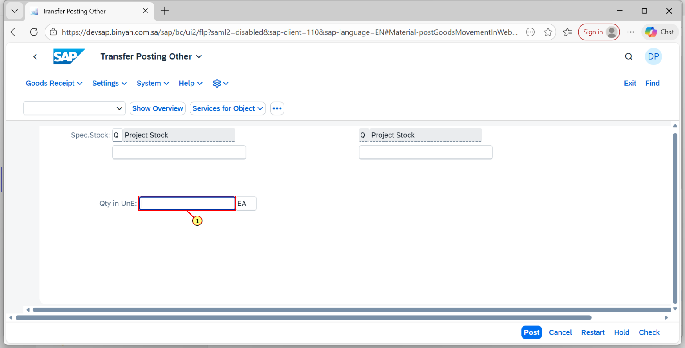
Step | Action
(1) | Enter "Quantity".

Transfer Posting Other - Personal - Microsoft​ Edge
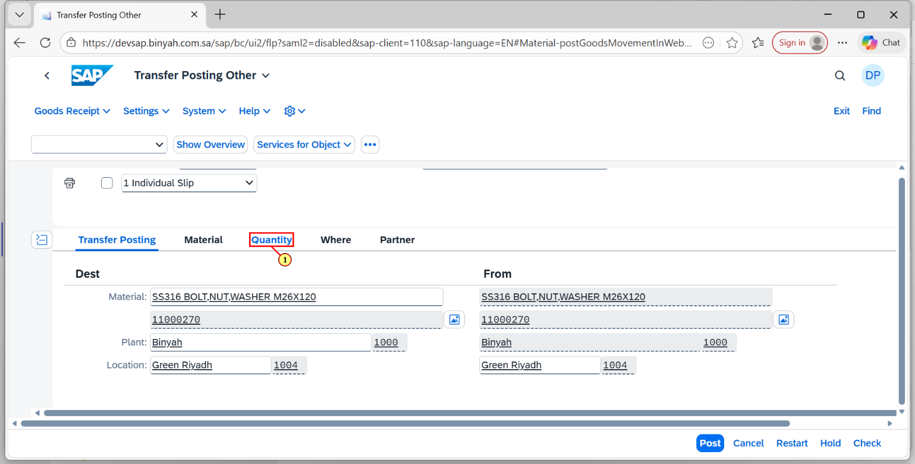
Step | Action
(1) | Now Click on "Quantity" Tab.

Transfer Posting Other - Personal - Microsoft​ Edge
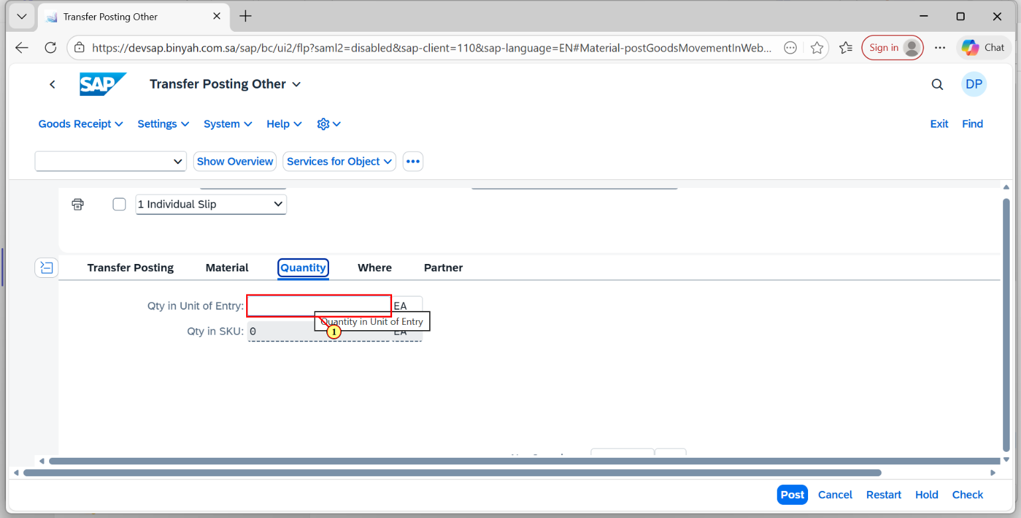
Step | Action
(1) | Fill out the Quantity Here.

Transfer Posting Other - Personal - Microsoft​ Edge
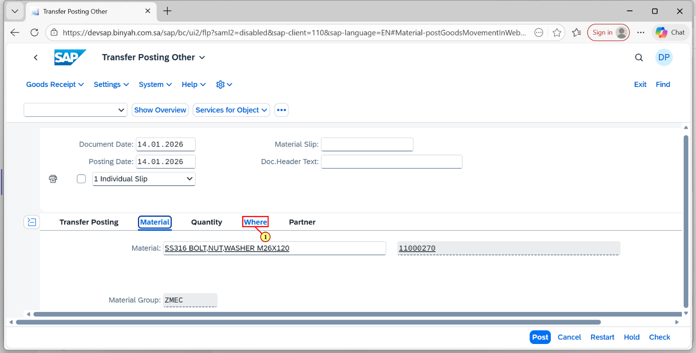
Step | Action
(1) | Click on "Where" Tab.

Transfer Posting Other - Personal - Microsoft​ Edge
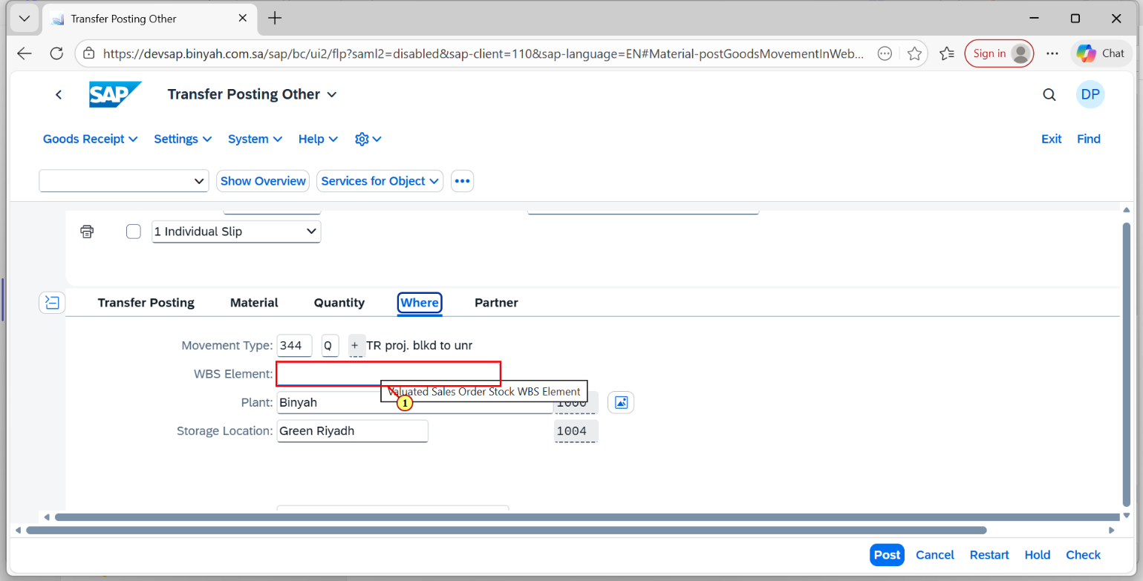
Step | Action
(1) | Enter the "WBS Element".

Transfer Posting Other - Personal - Microsoft​ Edge
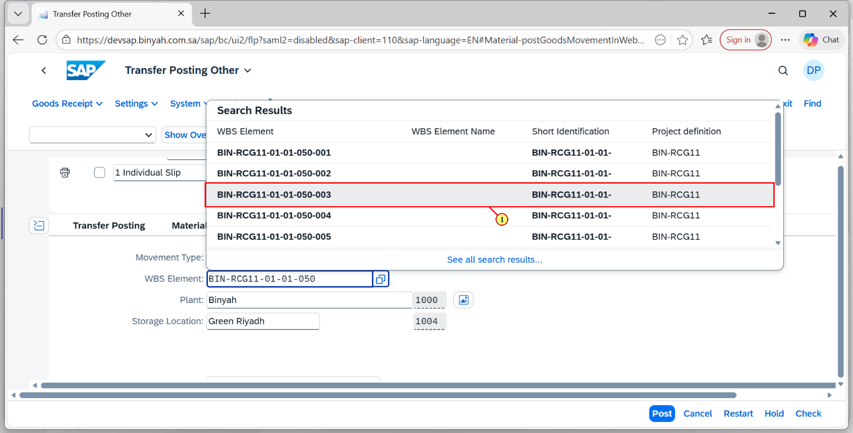
Step | Action
(1) | Choose "WBS Element" and Click "Enter".Now "Check" and "Save".

Transfer Posting Other - Personal - Microsoft​ Edge
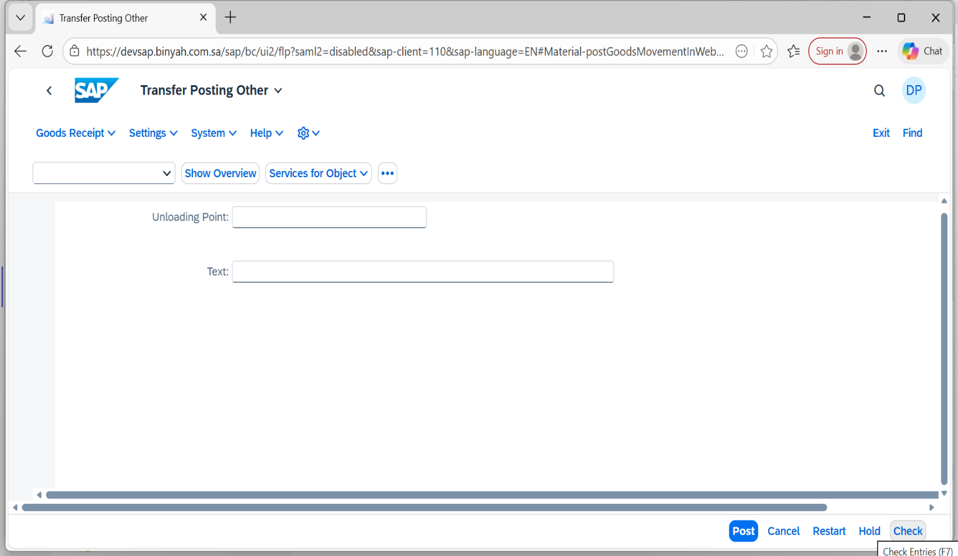
Step | Action
(1) | Click on “Check”.

Transfer Posting Other - Personal - Microsoft​ Edge
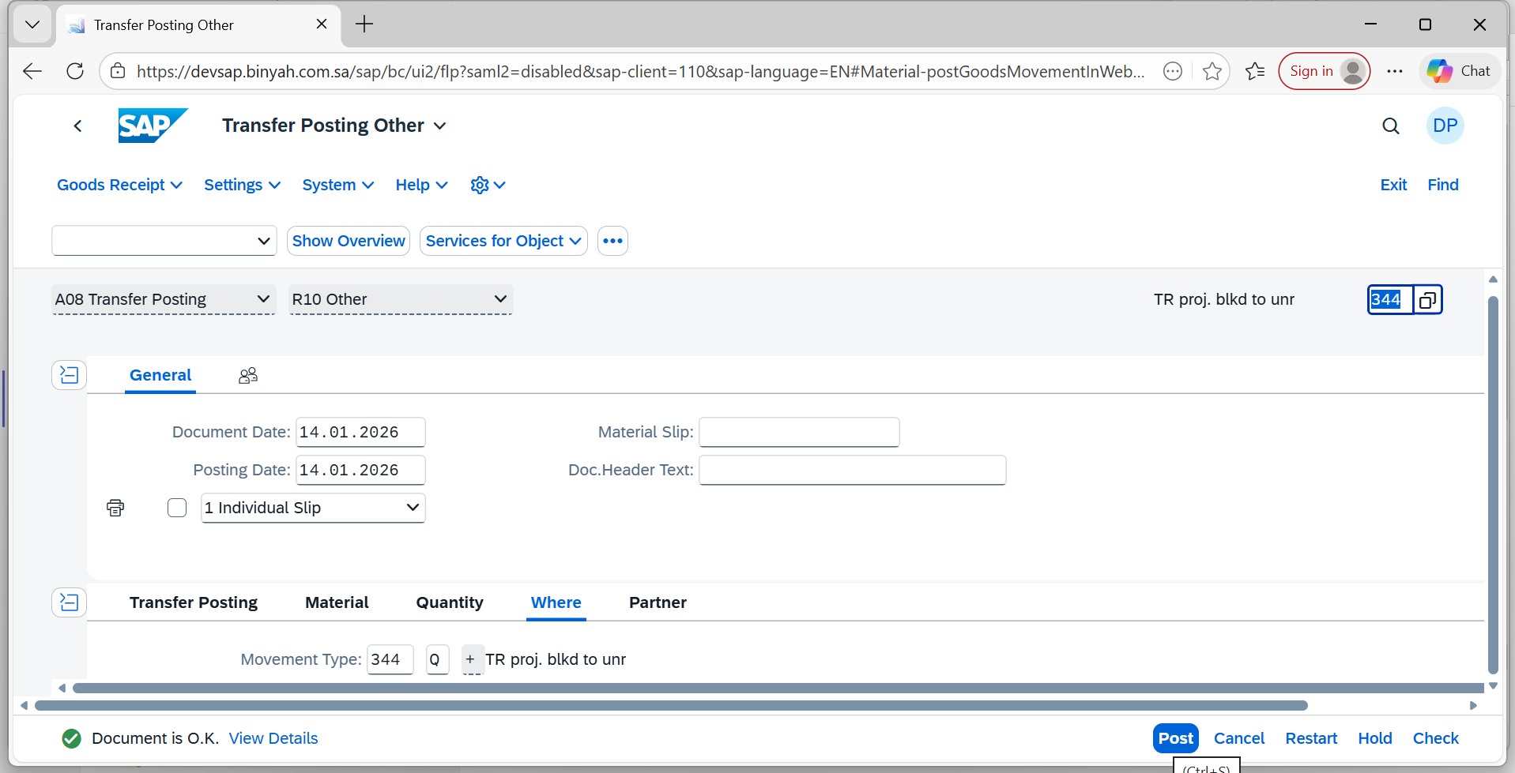
Step | Action
(1) | Click on “Post”.

